**Step 1 - Create a Snowflake catalog**

From the catalog page, select the **Create Catalog** button to create your second catalog.

Choose **Snowflake**.

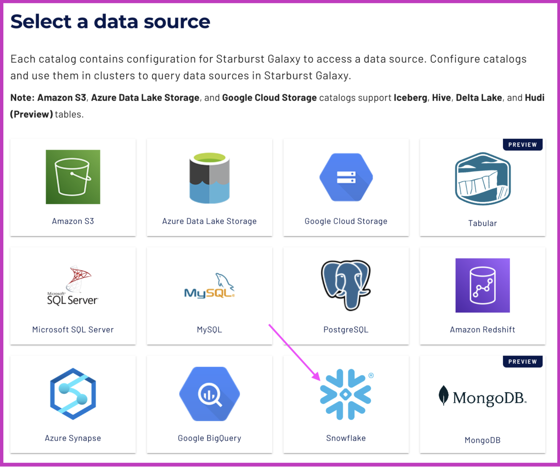

Using the list below as a guide, configure your catalog to query objects in Snowflake, specifically the zone information. Provide the necessary credentials to authenticate the connection.

**Cloud Provider:** AWS

**Catalog Name:** taxi_zone_lookup

**Description:** Taxi zone lookup information for NYC

**Snowflake account identifier:** TB03263.us-east-2.aws

**Username:** STARBURST_101_USER

**Password:** BTRhm2012!

**Database name:** NYC_RIDESHARE

**Warehouse name:** SB_101

**Snowflake role:** STARBURST_101

**Test** the connection to ensure that the setup is correct.

Select **Connect catalog** to save the credentials for your Snowflake catalog.

**Step 2 - Save access controls**

Next, set the default permissions for your catalog by selecting the **Save access controls** button.

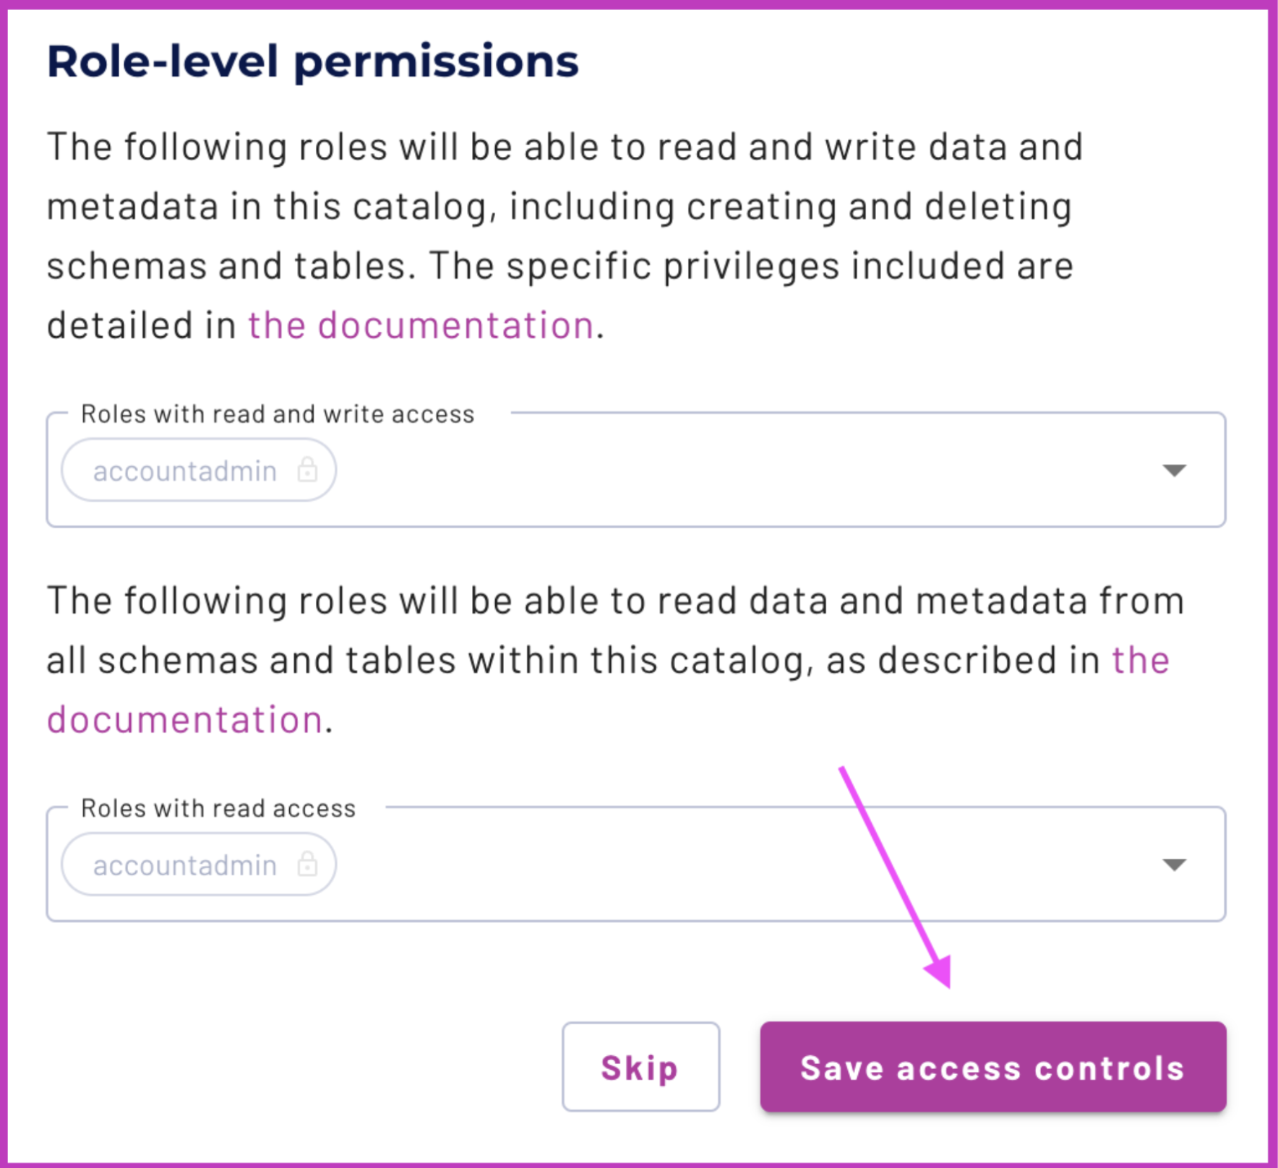

**Step 3 - Skip Add to cluster**

Finally, you will be asked if you want to add your newly created catalog to a cluster. This is not needed, so select **Skip**. You will create a cluster later in this lab.

